CURRICULUM VITAE
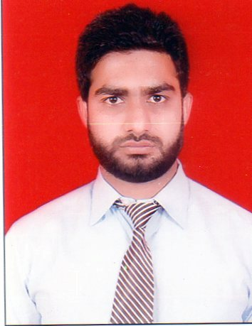

MOHD UVAIS

Mob: +919650982696 ,9568990780

Email: Ghaziowais@gmail.com

CAREER OBJECTIVE:
To work in an environment where there is a chance to gain knowledge which can be shared and enriched, where I can utilize my skills and expertise to the optimum towards achieving my goal.

WORK PROFESSION:
- Company Name : AnemoEngineers Pvt Ltd
- Designation : Design Engineer
- Work Duration : May 2017 to till now
- Project Handel : IIT MANDI, ENI GHANA (S.AFRICA), MINDA ONKYU, MLCP GURGAON, DENSO JHAJJAR, MAGNETY MARELI MANESAR
Company Profile: Anemo Engineers Pvt Ltdis specialize in designing, engineering, and installation of complete Heating, Ventilation and Air Conditioning Systems. Organization are uncompromising integrity, unequaled service and effective project management make us the value leader in this market.

WORK PROFILE INCLUDES:
- Reading Drawing
- Heat Load Calculation (By E20 sheet) & HAP4.3
- Selection of Equipment’s for low side (AHU, FCU,Grill,Diffuser,louvers,Insulation,VCD)
- Duct sizing (Using Ductulator)
- Duct & Pump Static Calculation.
- Selection of Equipment’s for High sides (Chillers, Cooling Tower, Pumps)
- Chilled water & Condenser Water Pipe Sizing and Routing.
- Ventilation & Exhaust of the Basements in Normal & Fire conditions.
- Ventilation, Exhaust & Spot Cooling of Kitchen, Laundry etc.
- Ventilation & Exhaust of Mechanical/Electrical Plant
- BOQ preparation
- VRV/VRF Systems
- HVAC Electrical SLD
- HVAC Equipment Specification

- Company Name : S.K Design Consulting Services
- Designation : Design Engineer
- Work Duration : May 2015 to May 2017
- Project Handel : Hayatt Hotel Allahabad, KPS Ghaziabad, CT University Ludhiana, Senior India FlexonicsManesar, Maingi farm house Jalandhar,PunjabKesri Jalandhar.
Company Profile: S. K. Design Consulting Services is outsourcing company for HVAC Designing & Drafting field from 2007 and mainly works for U.S and Middle East projects. Mainly they design Hotels, Clean room, Hospitals, Pharmacy Plant, Residential, Commercial and Industrial Buildings.

TECHNICAL QUALIFICATION:

- B.tech (Mechanical) from Lovely professional university, Punjab with 7.0 CGPA in 2015.
- Zakir Husain S.S School, Aligarh (CBSE), with 60.05 % in 2010.
- Class X from K MayawatiKanya inter college,Etah(UP Board) with 58 % in 2008

COMPUTER SKILL:

HAP (Hourly Analysis Program), RevitMEP, Auto-CAD 2010, M. S. Office, Excel,

PROJECT UNDERTAKEN LAST SEMESTER:

- Aerodynamic Study of Shuttle Cock (During B.tech)

KEY STRENGTH:

- Ability to adapt quickly
- Good team player
- Honesty
- Punctuality
- Hard working

PERSONAL PROFILE:

Name : MohdUvais
Father’s Name : Mohammad Zahid Husain
Date of Birth : 11 July 1991
Language Known : English, Hindi, Urdu
Permanent address : Super Colony Bhujpura J K Lodge,Aligarh (U.P).Nationality : Indian
Marital Status : Single

DECLARATION:

I hereby certify that the information furnished above is correct and complete to the best of my knowledge and belief.

Delhi (MohdUvais)

